- 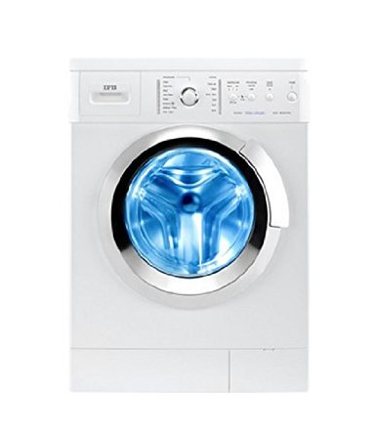
- IFB Elena Aqua VX Fully-automatic Front-loading Washing Machine (6 Kg, White)
by IFB
4.7 out of 5 stars 6 customer reviews

Price: | 28,690.00
Sale: | 23,999.00 FREE Delivery.Details
You Save: | 4,691.00 (16%)
 | Inclusive of all taxes
EMI starts at 2,143.53 per month. Options
In stock.
Sold by Cloudtail (4.4 out of 5 | 465,597 ratings) and Fulfilled by Amazon.
10 offers from 23,999.00
- Installation: For requesting an installation/demo for this product once delivered, please call IFB support directly on 1860-425-5678 and provide the product's model name
- Fully-automatic front-loading washing machine; 6 kg capacity
- 15 wash programs
- 4 years warranty
- 2D Shower system adds dynamic movement to the water and ensures that you get a cleaner and fresher wash for your clothes anytime
- Aqua energy is a special built-in aqua filter that treats hard water improving the life and performance of your machine
- Protective rat mesh is an additional cover at the bottom of the machine protects against possible damage caused by rodents

- 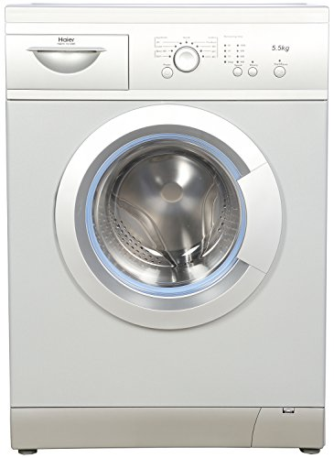

Haier HW55-1010ME Fully-automatic Front-loading Washing Machine (5.5 Kg, Silver)
by Haier
3.8 out of 5 stars 4 customer reviews

Price: | 22,490.00
Sale: | 19,055.00 FREE Delivery.Details
You Save: | 3,435.00 (15%)
 | Inclusive of all taxes
EMI starts at 1,701.94 per month. Options
Sold by Cloudtail (4.4 out of 5 | 465,602 ratings) and Fulfilled by Amazon. Gift-wrap available.
3 offers from 19,055.00
- Installation: For requesting an installation/demo for this product once delivered, please call Haier support directly on 1800-102-9999 and provide the product's model name
- Fully-automatic front-loading washing machine; 5.5 Kg capacity
- 9 wash programs
- 5 years warranty on USPs
- Quick wash, shower rinse and AMT gasket
- Homocentric drum and foam detect function
- Front loading washing machines are water and energy efficient, making them an environmentally friendly option

- 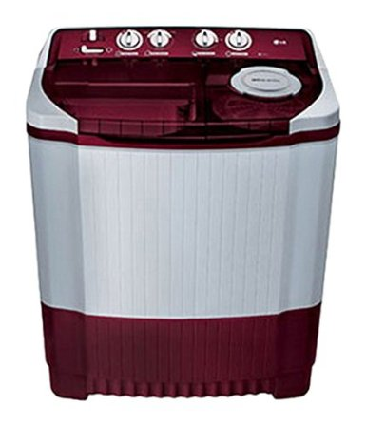

LG P7853R3SA Semi-automatic Top-loading Washing Machine (6.8 Kg, Burgundy)
by LG
Be the first to review this item

Price: | 12,890.00
Sale: | 11,606.00 FREE Delivery.
You Save: | 1,284.00 (10%)
 | Inclusive of all taxes
EMI starts at 1,036.62 per month.
In stock.
Sold by Cloudtail (4.4 out of 5 | 465,649 ratings) and Fulfilled by Amazon. Gift-wrap available.
12 offers from 11,500.00
- Installation: For requesting an installation/demo for this product once delivered, please call LG support directly on 1800-180-9999 , 1800-315-9999 and provide the product's model name
- Semi-automatic Top-Loading washing machine; 6.8 Kg capacity
- 4 wash programs
- 2 years warranty on the product
- LG puts technology to best use with its latest range of semi-automatic washing machines that come with rat away
- The rollers causes added friction to the clothes, removing dust and mites
- Punch+3 features one main pulsator and three mini pulsators around

- 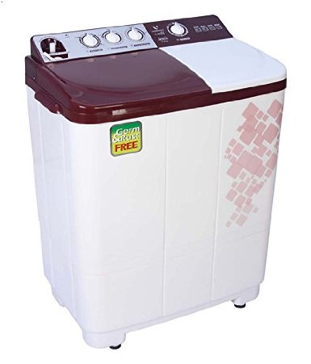

Videocon VS72H11 Semi-automatic Top-loading Washing Machine (7.2 kg, Gracia Dark Maroon)
by Videocon
4 out of 5 stars 4 customer reviews

Price: | 10,290.00 FREE Delivery.Details
 | Inclusive of all taxes
EMI starts at 919.07 per month. Options
Only 2 left in stock.
Sold by Easy Home (4.2 out of 5 | 108 ratings) and Fulfilled by Amazon. Gift-wrap available.
8 offers from 10,200.00
- Installation: For requesting an installation/demo for this product once delivered, please call Videocon support directly on 18002000111 and provide the product's model name
- 2 wash programs
- 2 year warranty
- Multi pulsator, centre waterfall, magic filter, anti bacteria technology, collar scrubber, body graphics
- Opaque window, PP body, chrome knob, anti-rust plastic body, pre-wash soak, buzzer
- Installation: For requesting an installation/demo, Amazon.in will ensure that the brand calls you to fix an appointment at a time of your convenience. In case of any delay, please contact us on our dedicated Toll Free Number 1800-3000-9027. We will follow up with the brand and ensure that it is taken up on priority
- Charges: Any installation/demo is chargeable ranging from Rs 300 to Rs 1500 depending up on the product & brand. We would encourage you to check with the brand when they reach out to you
- Note: For all semi-automatic washing machines and refrigerators, installation is not provided by the manufacturer

- 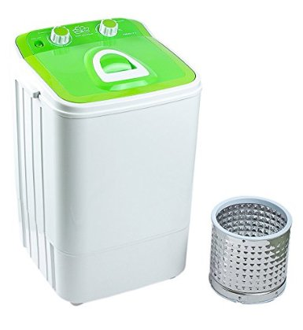

DMR 46-1218 Single Tub Washing Machine with Steel Dryer Basket (4.6 kg, Grey)
by DMR
4.1 out of 5 stars 13 customer reviews

M.R.P.: | 5,999.00
Price: | 4,299.00 + Delivery charges may apply
You Save: | 1,700.00 (28%)
 | Inclusive of all taxes
EMI starts at 383.97 per month.
In stock.
Sold and fulfilled by Lakshmi Electronic (4.1 out of 5 | 43 ratings).

Color: Green

- Single tub portable washing machines; 4.6 kg capacity
- 1 Years Comprehensive Warranty from DMR
- Package contents: Washing machine, Inlet pipe, Drain pipe
- Installation: For requesting an installation/demo, Amazon.in will ensure that the brand calls you to fix an appointment at a time of your convenience. In case of any delay, please contact us on our dedicated Toll Free Number 1800-3000-9027. We will follow up with the brand and ensure that it is taken up on priority
- Note: For all semi-automatic washing machines and refrigerators, installation is not provided by the manufacturer

